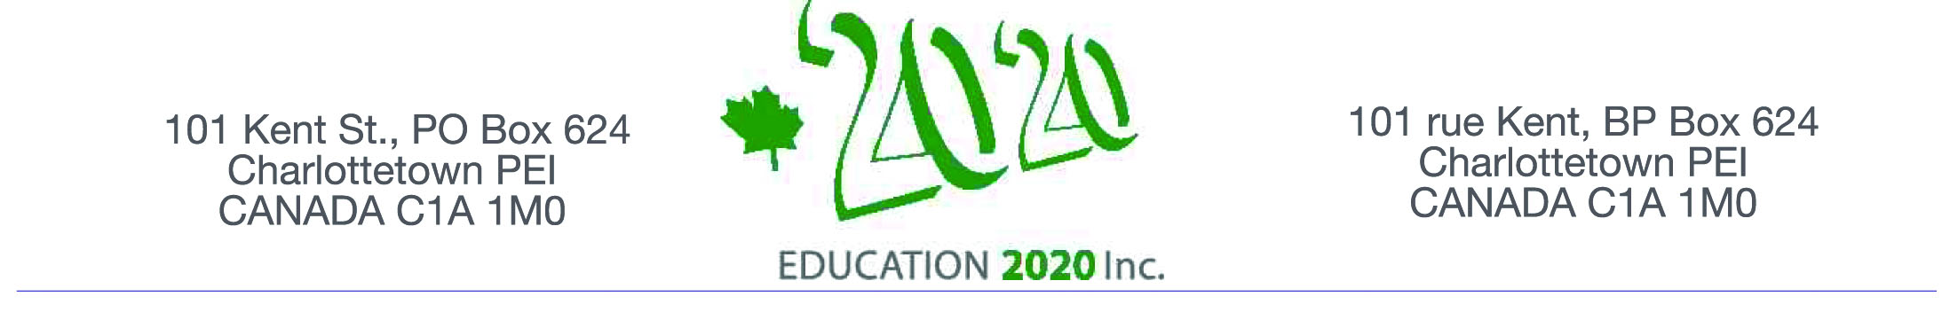

On behalf of Education 20/20 Inc.
I am pleased to invite you to a presentation by
Dr. Tammy Hubley-Little.
Leader of Curriculum Delivery for the English Language School Board
on the topic of

Student Achievement - Improved Outcomes Through Equity

The event is informal and will provide opportunities to meet and talk
to others who share an interest in education.
The session, the first of a series of conversations with Island educators,
will be held at the

Haviland Club from 4-6:00 pm
Wednesday, January 21, 2015

Dr. Hubley-Little has taught pre-school, secondary and post secondary education in the private and public sectors in England, Norway and Canada;
she holds a Master's degree in Counseling, Master of Arts in Education,
and a Doctorate from Durham University in England.
She and her husband have three daughters and a grandson

I look forward to seeing you on January 14.
Don Glendenning, President

Space is limited so an early RSVP is requested
Email: pei@education2020.ca

Education 20/20 inc. is an independent, broad based, national, not-for-profit education organization located in Charlottetown; its mission is to support a quality education for every Canadian.

